Internship Orientation Meeting Minute

* Sign-up for Microsoft Teams
  + Platform for chats + meetings
* Weekly Meeting – Friday 10-10:30 AM
  + Prepare 1-2 slide update (Max 3 min)
* Daily Meetings will be arranged separately.
* Messaging and Meetings
  + Use “Channels” in Microsoft Teams
  + Collaborate with other students.
  + Extraordinary meetings two days in advance
* Weekly meeting, 1-2 slides
* Halfway progress presentation
* End of internship presentation
  + Final report

Reading Materials

* Zotero – reference organization software
  + Create an account.
* General review papers on neural interfaces

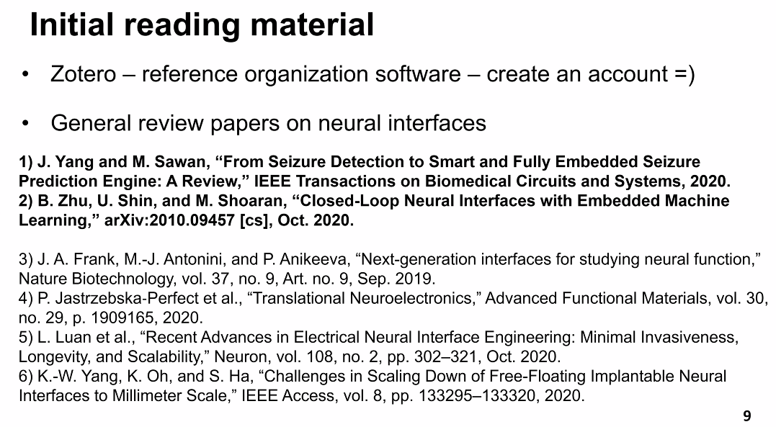

Project description update

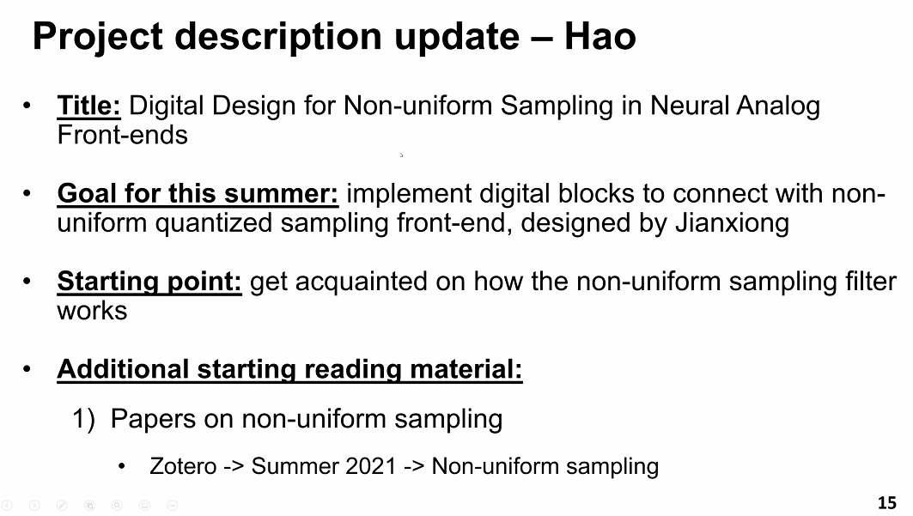

Acquainted with the software Vivado (like Quercus)

* Vivado (40 Gb)

Action items for now:

Review papers #1 and #2

Read other review papers if interested.

For FPGA folks: install Vivado and begin the tutorial